Manuscript Template
The information of authors and affiliations should be listed on a separate Title Page Template

⦁ Manuscripts should be written in MS word processor in A4/Letter paper size, 10-12 points in font size.
⦁ Manuscripts should be double spaced, and the continuous page numbers at the bottom and line numbers at the left must be included.
⦁ When marking references cited in the text, pay attention to the following points.
① Place a period (.) or comma (,) after a citation (Kim, 2019).
② When citing references, the first author's last name and publication year are indicated at an appropriate location in the text.
(Example)
For single author: According to Kim (2019), it was reported as ... /... (Kim, 2019).
Two authors: Kim and Lee (2019) reported ... /... reported (Kim and Lee, 2019).
Three or more authors: Kim et al. (2019) reported ... /... reported (Kim et al., 2019).
Multiple references by the same author: Kim et al. (2019a) ... /... Smith et al. (2019b).
Two or more references: reported as ... (Kim, 2019; Lee, 2019).
③ References are arranged in alphabetical order by author name and publication year.

Title
(Example)
Effects of processing and storage methods on the quality characteristics of kimchi (less than 250 characters)

Abstract
⦁ Abstract should be a clear, concise (180-220 words), and one-paragraph brief summary with spaces between words and parentheses.
⦁ Abstract should include the research purpose, experimental approach, significant results, and major conclusion as well as important applications. Also, non-standard or uncommon abbreviations should be avoided, but if essential they must be defined at their first mention in the abstract itself.

Keywords:
⦁ Maximum of 5 keywords representing the content of the manuscript should be provided to aid the reader in literature retrieval.

(Example)
Keywords: apple juices, processing, storage, quality, kochujang

(Scientific names and proper names (traditional food, etc.) are written in italics; Variety name is in capital italics, Tongil)

1. Introduction
⦁ The introduction describes a theoretical background, indicates why the work is important, address a specific research question, and presents a specific hypothesis to be verified. The last sentence should provide the purpose and rationale of your study.
⦁ In the text, the scientific name is first mentioned as the full name, and the generic name is abbreviated thereafter. (Example) Malus domestica → M. domestica
⦁ In the case of abbreviations in the text, the full name is written first, and only the abbreviation is written afterwards. (Example) modified atmosphere packaging (MAP) → MAP

2. Materials and methods
⦁ The specific specification, quantity, and source of the material must be clearly indicated, and when the product is purchased, it is specified in parentheses, such as 'name of substance [manufacturer, region of manufacture (city in Korea, city and state in USA), name of country]'.
⦁ Experimental equipment, devices, software, etc. should be specified in parentheses, such as ‘device name [model (version) name, manufacturer, manufacturing region (city in Korea, city and state in USA), country name]’.
⦁ In the case of the same product, only the model and manufacturer name are described thereafter. If the name of a substance or device is not an abbreviation or proper noun, the first letter is written in lowercase.

(Example)
spectrophotometer (Light 500, Vision Co., Seoul, Korea)
glucose (Sigma Chemical Co., St. Louis, MO, USA)
HPLC (Waters 600, Waters Co., Ltd., Miliford, MA, USA)
IBM SPSS Statistics (19, IBM Corp., Armonk, NY, USA)

⦁ In principle, the units (SI, cgs) according to the regulations of the journal should be used (eg, mL, L, μL, μg, etc.), and ‘(w/v)’ mentioned in %, etc., are written in lowercase letters.
⦁ Units are written with a space followed by a number. However, at 10℃, 10%, etc. are exceptions.
Use '-' to indicate a range of numbers, etc. in the text. (ex.) 10-20℃, 5-10 days, etc.

2.1. Materials
2.1.1. Food materials
(text)
2.2. Sensory evaluation (or animal research)
⦁ Sensory evaluation and animal and clinical research should be performed after obtaining approval from the Institutional Review Board (IRB) or the Institutional Animal Care and Use Committee (IACUC) of the affiliated institution. The approval number and date of approval must be recorded.
(text)
2.3. Processing and storage conditions
2.3.1. Pretreatment conditions
(text)
2.4. Measurement of quality characteristics
(text)
2.5. Statistical analysis
For statistical analysis, the number of replications of the experiment and mean ± standard deviation (SD) or standard error (SE) (n= ) of the data should be indicated. Statistical program and significance indication should be clearly stated, and the results of tables or figures should be displayed in accordance with the explanation in the text. The significance level of statistical analysis is expressed with a lowercase letter p, not italic type (p<0.05).

3. Results and discussion
⦁ The contents of results and discussion must be consistent with the writing order of the research method section
⦁ Experimental values ​​should be presented in tables or figures after statistical analysis. If a table or figure needs to be omitted, mark ‘(data not shown)’ at the end of the sentence mentioned in the text.
⦁ Discussion should be stated based on the experimental results and objective references.

3.1. Effect of storage and processing conditions on apple color
(text)
3.2. Changes in microbial load during storage
(text)

4. Conclusions
In conclusion, the purpose of the study and the validity of the results, application and future plans
should be mentioned based on the outline of the study results.

Supplementary Materials
If applicable, supplementary material to be presented is provided as a file.

References
⦁ References list in alphabetical order by author name and publication year.
⦁ If the English title is not included in the original text, it is translated according to the meaning.
⦁ The abbreviation of periodicals is ISI Journal Title Abbreviation Index.
⦁ An example of the notation of References is as follows.
(Example)
AOAC. Official Methods of Analysis. 15th ed, Association of Official Analytical Chemists, Washington DC, USA, p 210-219 (1996)
Hong KD. Development of Preservation Method for Apple's Improvement. Final Report of KOSEF, KOSEF 98-02-12345-02 (1998)
Kim HG. Effects of processing and storage methods on the quality characteristics of Korean pear juices. Ph.D. Thesis (or MS Thesis), Daehan University, Korea, p 40-43 (2011)
Kim KD. New technology of apple storage. USA Patent No. 111000 (1998)
Kim YN. Changes of polygalacturonase during softening of sweet potatoes. Paper presented at 18th Annual Meeting of Korean Society of Food Preservation, August 20, Daegu, Korea (2002)
Lee KD, Kim KS, Park AB. Influence of postharvest treatment on storage of apple. Korean J Food Preserv, 2, 11-23 (1993)
Obeime D. Modified atmosphere packaging of fruit and vegetables. In: Chilled Foods, Golmley TR (Editor), Elsvier Applied Science, London, England, p 50-100 (1990)
Ryall AL, Liton WJ. Handling, Transportation and Storage of Fruits and Vegetables. Avi Publishing Co, Westport, CT, USA, p 10-15 (1984)
SAS. SAS User's Guide: Statistics, 3th ed, SAS Institute Statistical Analysis System, Cary, NC, USA (1998)
MFDS. Detection and quantitation of acrylamide in foods. Available from:
https://www.mfds.go.kr. Accessed Dec. 10, 2021.

Tables and Figures
⦁ Tables, figure legends, and figures should be written on the separate sheet after the references of the manuscript, respectively.
⦁ All tables and figures should be written in such a way that the contents can be understood independently without referring to the text. Descriptions of abbreviations or symbols should be written in all tables and figures, not as references to specific tables or figures.
⦁ Significance levels of statistical analysis results are indicated by ^{a, b, c, d}, etc., and by *, **, ***, etc. in the multi-range test.

(Example)
Table 1. Changes in vitamin C content affected by storage condition (Capitalize only the first letter)
⦁ The title of table is written in bold and all columns are aligned on the left.
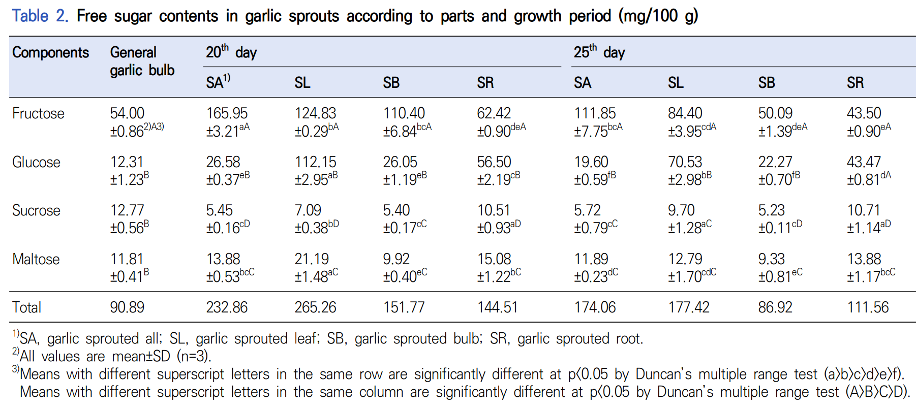
⦁ When adding footnotes, add ^{1), 2) and 3)} to the end of the value, symbol, word or sentence you want to explain in the table contents. Footnote explanations end with a period (.).

(Example)
Fig. 1. Changes in vitamin E content of apple during storage. (Capitalize only the first letter)
⦁ The title of the figure is written in bold at the bottom of the figure and ends with a period (.).
⦁ Values, symbols, words, etc. to be explained in the figure are explained as footnote explanations that end with a period (.).
⦁ All figures must be written clearly in Arial font.
⦁ The axis tick (tic) in the figure is marked only inward.
⦁ If there are two or more pictures in one figure, they are divided into (A) and (B).
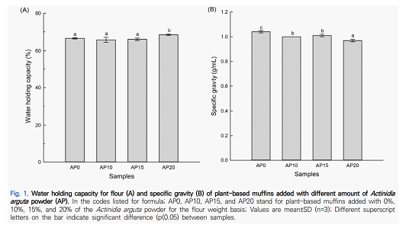
(Example)
Fig. 1. Changes in vitamin E content of apple during storage. ●, 0℃; ○, 5℃; ■, 10℃; □, 5℃.
Values are mean±SD (n=3) and different superscript letters on the bar indicate significant
differences (p<0.05) by Duncan’s multiple range test.

【 Units and Abbreviation 】
Correct | Incorrect | Correct | Incorrect
【 Unit 】
2 cm (centimeter) | 2 cms, 2cm, 2 cm. | K (absolute degree; Kelvin) | ºK
2 m (meter) | 2 M | pH 7.0 | PH 7.0, pH7.0
1 μm (micrometer) | 1 μ, 1㎕, 1μm | 15 cP (centipoise) | 15 CP, 15 cps., 15 cp
27 g (gram) | 27g, 27 gr, 27 grs. | 20 MPa (mega pascal) | 20 mPa, 20 mpa,  20 Mpa
30 kg (kilogram) | 30kg, 30 Kg, 30kgs. | 18,000 ×g (gravity) | 18,000 ×g, 18,000×g, 18000g
30 mL (milliliter) | 30 ml, 30 ㎖, 30mL | 2 log CFU | 2 log cfu, 2 Log CFU
50 L (liter) | 50 l, 50 l, 50l, 50L | 15 ºBrix | 15ºBrix
2.5 h (hour) | 2.5 hr, 2.5 hr., 2.5 hrs, 2.5 hrs | 15 kg_{f} | 15 Kg_{f}, 15 kgf
3.5 min (minute) | 3.5min, 3.5 mins. | 【 Range 】
20 sec (second) | 20 s, 20 sec. | 0.3-0.9 g | 0.3~0.9 g, 0.3 - 0.9 g
60 mm/min | 60 mm/min., 60mm/min | 【 Formula 】
25 m/sec | 25 m/s, 25 ms⁻¹ | (a+b)/(c+d) | a+b/c+d, (a+b)/(c+d)
25% (percent) | 25 % | 【 Abbreviation 】
20%(w/v) | 20% (w/v), 20%(W/V) | OD (optical density) | O.D, O. D.
0.54 mg% | 0.54mg%, 0.54 mg % | DE (dextrose equivalent) | D.E, D. E.
25 ppm | 25ppm, 25 PPM | ND (not detected) | N.D, N. D.
1×10⁻³ M (molarity) | 1x10⁻³M, 1 x 10⁻³ M | SD (standard deviation) | S.D, S. D.
0.01 N HCl | 0.01N HCl, 0.01N-HCl | NS (not significant) | NS (non-significance)
30℃ | 30 ℃ | USA | U.S.A., U.S.A, US

